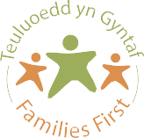



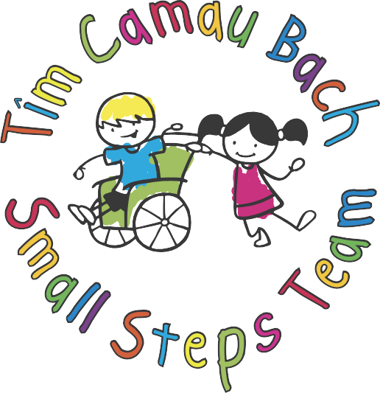

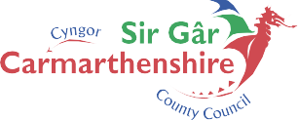




FOR FURTHER INFORMATION PLEASE CONTACT -
01267 246673 / 07785 276035
Email: ClareGriffiths@carmarthenshire.gov.uk
Web address: https://fis.carmarthenshire.gov.wales/tim-camau-bach-disability-support/

Camau Bach are offering a relaxed get together, for Parents and Carers of Children who have Additional needs

Do you need support?

Get advice from experienced staff

Have the opportunity to meet other parents

Access to specialist sensory equipment

Special Guest Speakers.

Every Tuesday 10am—12pm
Llys Caradog Children's Centre
Llwynhendy, SA14 9HE

Term Time Only

Camau Bach are a specialist project who support children who have disabilities, (diagnosed or undiagnosed) and their families.

We support children aged 0—16yrs.

