Summary of Employment Engagement Programmes – April 2021- March 2022

Working alongside partners we will be adopting a one team approach to tackling poverty in the most deprived areas across Carmarthenshire. The Employment Engagement Programmes will be delivered through a variety of funding streams, which are European Social Fund, Museum Archive and Libraries Division, DWP, The Children and Communities Grant and the Welsh Government. The funding streams enable the delivery of the Communities for Work, Communities for Work Plus, Legacy and Fusion Programmes and become a gateway for the Kickstart scheme.

The one team approach will provide an efficient delivery model, ensuring consistency. This will be beneficial to the partners, stakeholders and individuals who access the programmes, prevent duplication and ensure that resources are maximised to add value to all of the outcomes. Aligning as one team enables pathways for the individual to receive the support required.

There is a triage process in place, which will continue to be administered. The Triage Officer role sits within Communities for Work but is a shared function between the projects. The Triage Officer acts as an ‘honest broker’ for all projects within Carmarthenshire, ensuring that any referrals are sign posted to the most suitable support for them. Update meetings with other partners such as the jobcentre Plus, Careers Wales etc take place on a regular basis to ensure that any updates are clearly communicated. The following is the process adopted by Carmarthenshire:
There has also been the development of an online form that individuals can access: www.carmarthenshire.gov.wales/employmentsupport www.sirgar.llyw.cymru/cymorthcyflogaeth
The priority for all programmes is the individual with their need’s central to the delivery models. Individuals will receive the following support.

- One to one mentoring using a variety of techniques
- Personal Development Plan
- Identification of barriers, goals and aspirations
- Regular reviews and ongoing monitoring
- Support to access employment and placement opportunities
- Creating and enhancing CVs and preparing for interviews
- Funding to access support to remove barriers
- Access to training courses

Communities for Work

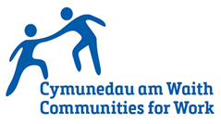
Communities for Work (C4W) is a Welsh Government EU funded programme tackling poverty through sustainable employment providing intensive employment mentoring and support. Communities for Work is a voluntary programme to help those adults furthest away from the labour market into employment. The programme focuses on our most deprived communities, and provides 1-to-1 support, guidance and training. The programme is able to offer community-based support, training, barriers funding to help people into training or employment and working alongside key partner organisations. The programme will focus on reducing the number of 16 – 24 year olds who are Not in Education, Employment or Training (NEET) and increasing the employability of economically inactive and long term unemployed adults who have complex barriers to employment.The team work on an outreach basis across Communities, with bases at the Llanelli and Ammanford Hwbs.

Communities for Work Plus ( Children and Communities Grant)

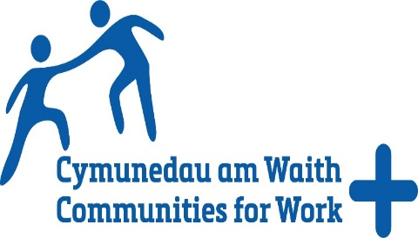
The main priority of the programme is to reduce the number of individuals that are unemployed through offering personalised support, focusing in the Llanelli Area. The Communities for Work Plus programme will create an infrastructure that will offer individuals a holistic package of support to meet their needs. Support will be extended outside of the current boundaries to include individuals that are not eligible for support through the Communities for Work, Pace or other regional European Social Fund (ESF) Programmes. The programme is delivered across Carmarthenshire and will work with the individuals furthest away from the labour market who are experiencing barriers to participation. This will be achieved through the following:
Creating opportunities that will upskill individuals through basic skills and vocational training support, work tasters, placements and support to achieve sustainable training and jobs. The selected delivery model for the programme aligns with the Welsh Governments Taking Wales Forward Strategy and reflects the commitment to reshaping employability support.
Communities for Work Plus (Additional funding)
The funding will be used to expand the team to ensure that we reach wider geographical areas across Carmarthenshire, with the team focusing on Ammanford, Carmarthen and the rural areas. Whilst the COVID pandemic restrictions are in place, there will be a blended approach to delivery which will consist of online training, digital appointments and telephone calls. When the restrictions are lifted, we will then resume face to face delivery with a presence at outreach venues across the County. The delivery will focus on an area team approach.

The training and barriers fund will be utilised to support individuals into training that are experiencing barriers. Each individual will receive intensive support from a Mentor, who will complete a training plan with them. This will help establish goals and ensure that the correct training is taking place to support them into employment.
Legacy Programme
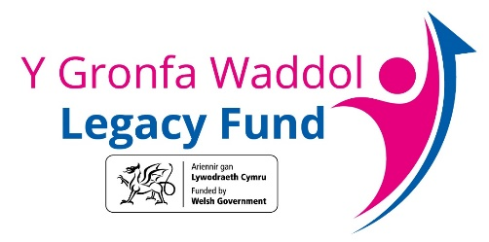
The vision of the Programme is to “tackle poverty by doing all we can to prevent it by helping people into work and improving the lives of those living in poverty” The aims of the Legacy programme are to support individuals who are furthest away from the employment programme and contribute to the Welsh Governments Employability Plan, by working with key partners and Welsh Government Programmes; to create opportunities for individuals to access employability support.
Eligibility will be for individuals that are resident in the most deprived communities in Carmarthenshire. Priority will be given to the areas that have Communities for Work status. There are three key projects that will be delivered through the programme. Each project has been designed to support individuals to overcome barriers that are preventing them from accessing employability support, With the duration of the programme being funded for a year, eligibility will be for individuals that are looking to return/ enter employment within a year period.
Key priorities will be as follows.
- Reduce the gap in working age unemployment and economic inactivity rates between Wales and the UK average
- Reduce the gap between Wales and the rest of the UK at all qualification levels
- Provide Support to help reduce the number of NEETS who are not in education, employment and training
- Support individuals that have been affected by COVID
- Support individuals that have been furloughed, unemployed, in low/ zero-hour contract, individuals experiencing barriers as a result of disabilities,
- Support individuals to access self-employment opportunities

In line with the Welsh Government Employability Plan Model the following will be delivered.
- Delivery of the Skills for Employment Programme through working with the Regional Skills Partnerships, to identify areas of growth and required skills for the labour market.
- In line with the Welsh Government Employability Plan, deliver the Promoting Positive Lifestyle Programme to individuals where poor physical and mental wellbeing is a barrier to employment.
- Work with partners to engage with individuals that are not accessing employability services through specific outreach work and project delivery.
- Providing an individualised approach to support, and bespoke solutions for those in greatest need.
Fusion
The main priority of the programme is to support individuals living in the most deprived areas across Carmarthenshire through the delivery of a programme that contributes towards tackling poverty through Culture. The programme has embraced the recommendations in the Baroness Andrews Culture and Poverty report. Collaboration is critical to the delivery of the programme, with key strategic structures in place to support delivery at local levels. The delivery of the programme is prioritised in the most deprived areas across Carmarthenshire, with emphasis in the Communities for Work geographical areas. The funding has enabled the recruitment of a part time Cultural Officer to support the facilitation of the programme.
The focus within Carmarthenshire will be to upskill individuals through the creation of opportunities that will improve their prosperity, education and wellbeing. Within Carmarthenshire the delivery of the projects aligns with the Museum, Archives and Libraries Division 7 key strategic outcomes.
- Supporting the Early Years and Family Learning
- Gaining a qualification:
- Regular volunteering as route to work:
- Improved digital skills:
- Completing a work experience placement
- Improved attitude to formal learning:
- Better able to manage their mental wellbeing and physical health:

The outcomes then feed into the Welsh Government framework for the Wellbeing of the Future Generations Act.

Kickstart
Carmarthenshire Council have recently become a gateway for the Kickstart Scheme. The Kickstart Scheme provides funding for employers to create new job placements for 16-to-24-year olds on Universal Credit who are at risk of long-term unemployment. Employers are entitled to 100% of the National Minimum Wage for 25 hours per week, for a total of 6 months. The start date of the job placements is up until the end of December 2021.
There is also funding available for the individual to support them to improve their employability skills. As the gateway we will be working alongside the individual and the employers to establish an action plan. Support can include accredited and non-training and mentoring support. The aim is to improve the skill set of the individuals who access the scheme, which will support them to access sustainable employment.

