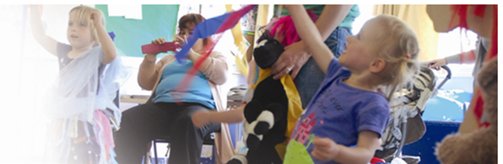
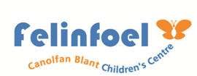
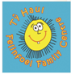
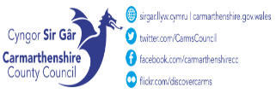
Felinfoel Children’s Centre Ysgol Maes Y Felin, Ynyswen Felinfoel Llanelli SA14 8BE 01554 742498

Tel No. 01554 742402
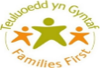
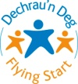 September- October 2025
FREE Come and Cook 9:30am-11:30am Join Andrew and Jo for some fantastic healthy cooking ideas on a budget which you can take home with you to feed the family!
15/09/2025- 20/10/2025

Courses & Workshops
9.15am– 11.15am

Join us for cooking and craft workshops

Family Fun Club
3.00-4:30pm
For families with children in lower primary school. Drop in after school for some family fun. Free play, crafts and after school snack.

Open Access Play
3pm - 4:30pm
A session for 7–11-year-olds where they can enjoy arts & crafts, outdoor play and so much more.

Hywel Dda Flying Start
Health Visitor
‘Drop in’ Clinic.
9:30am – 11:00am
Hywel Dda Perinatal
Support Clinic
Appointments Only

1:00pm – 3:00pm
Baby Massage
For Parents with Babies 0-6 months

Starting 11.11.14.
(for 5 weeks)
Referral only

Baby Group
9.30am – 11.30am
A drop-in session for parents & babies –ideal for all babies until they are more mobile and ready for toddlers.

Toddler Group
9.30am – 11.30am
Parent/Toddler group
Drop in session offering a warm welcome to all with free play, family activity time, outdoor play, snack and story/song time. For toddlers aged 0-3yrs.

12/06/24 – 17/07/24

Toddler Group/Tiny Talkers
9.30am – 11.30am
Parent/Toddler group
Drop-in session offering a warm welcome to all with free play, family activity time, outdoor play, snack and story/song time. For toddlers aged 0-3yrs.

3PM-4-30PM
Bespoke Perinatal course
12:30pm – 2pm

Course 1: 13th October – 10th November.

Closed Group.
Fare Share Group
1.00pm-1.30pm
A food redistribution scheme for families
Booking Only

WEDNESDAY

PM

Play Club
3pm - 4:30pm
A session for 4–6-year-olds where they can enjoy arts & crafts, outdoor play and so much more.

MONDAY
TUESDAY

AM
THURSDAY
FRIDAY

