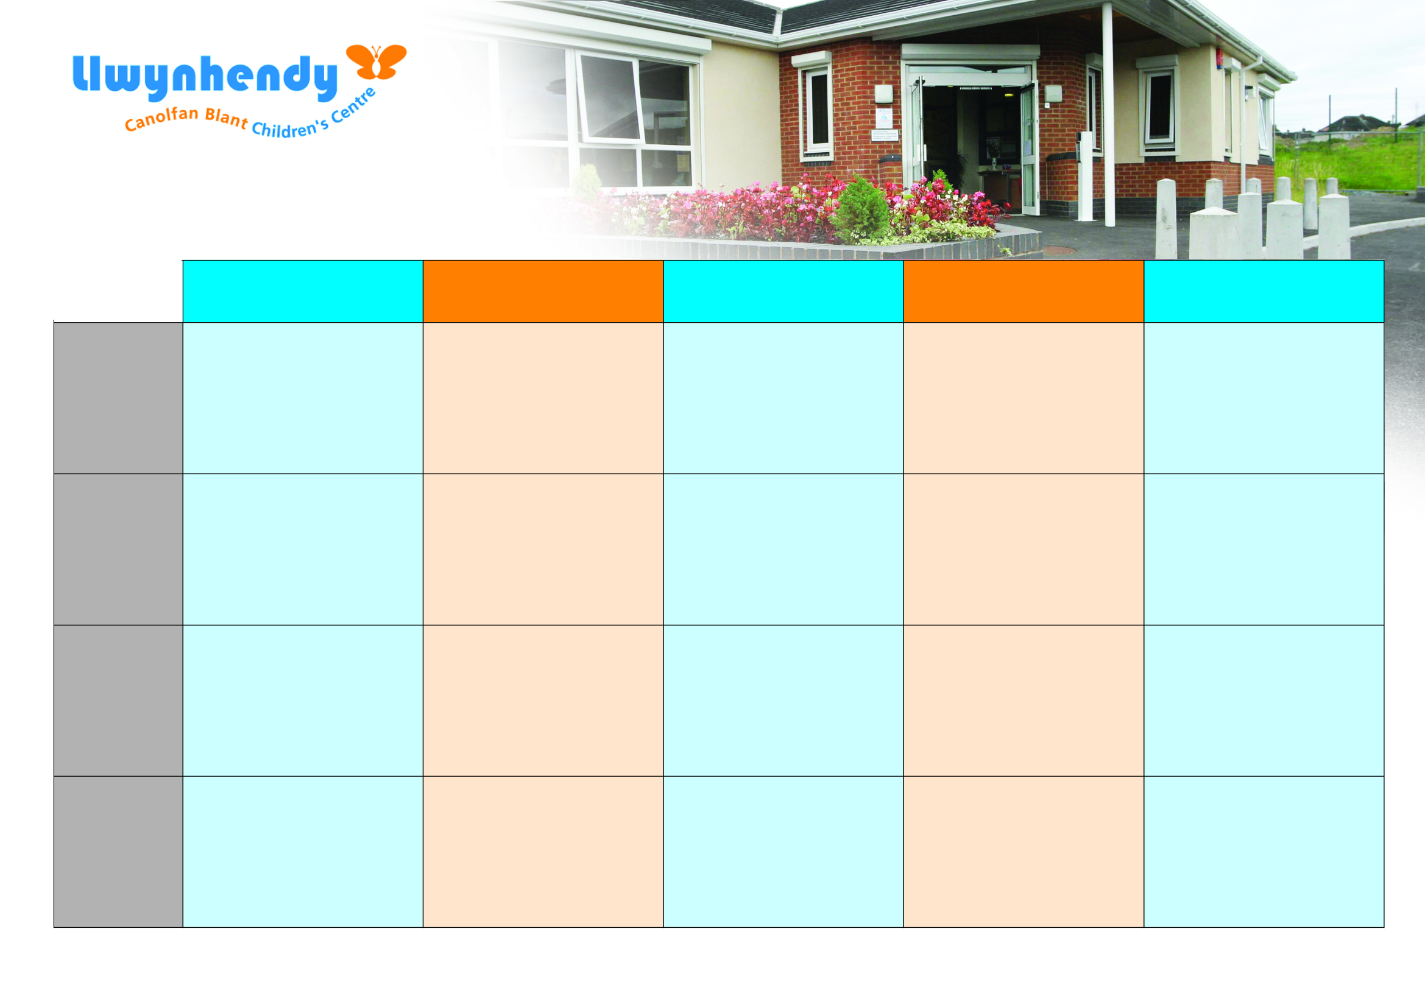

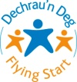
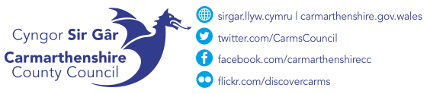

Llwynhendy Children’s Centre, Off Llwynhendy Road, Llwynhendy, Llanelli. SA14 9DP
01554 742203

Monday
Tuesday
Wednesday
Thursday
Friday
Morning

Afternoon

After school

Play Club
3pm-4:30pm
A session for 4–6-year-olds where they can enjoy arts & crafts, outdoor play and so much more.

Open Access Play
5.00pm-6:30pm
A session for 7–11-year-olds where they can enjoy arts & crafts, outdoor play and so much more.

Evening

Flying Start
STEPS parenting programme 9:30am-11:30am
Please book on via the Flying Start app.
16/09/2025 – 9/12/25

Tap, Tap & Chat (Baby Play)
12:30pm-2:00pm
Join us for some crafts, singing and story time whilst learning how to develop your baby’s language.
Group for babies who are non-mobile and who are crawling

Money Matters session with Threshold
9:30am-11:30am
A session all about learning different way to manage money and how best to save money day to day.

Please contact a member of staff for more details.

Dads Group
6pm-8pm
A group just for dads to get together over a coffee and a chat! Starting 24/09/2025

Baby Massage with Baby Yoga
09:30am-11:00am
Free 6-week Baby Massage course for babies 8 weeks- 6 months. Please contact us for more information
Starting 11/09/2025

Tiny Talkers (LAP)
9:30am-11:30am
Join us for some crafts, singing and story time whilst learning how to develop your child’s language.
For parents with children who are toddling up to 3 years old

Accredited First Aid course.
9:30am-11:30am

A 3-week accredited Paediatric First Aid course.
19/09/2025 – 1/10/2025

Antenatal closed group
12:30pm-2:30pm
Please see midwife for information.
(the first three Mondays in each month)

Flying Start Health Visitor Clinic
12:30pm-2:00pm

September – October 2025

Parenting Plus Early Years course
A parenting course designed to help those parents who are dealing with difficult behaviour from 0-5 years old. 25/9/25 – 23/10/25

