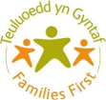
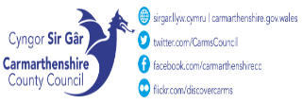
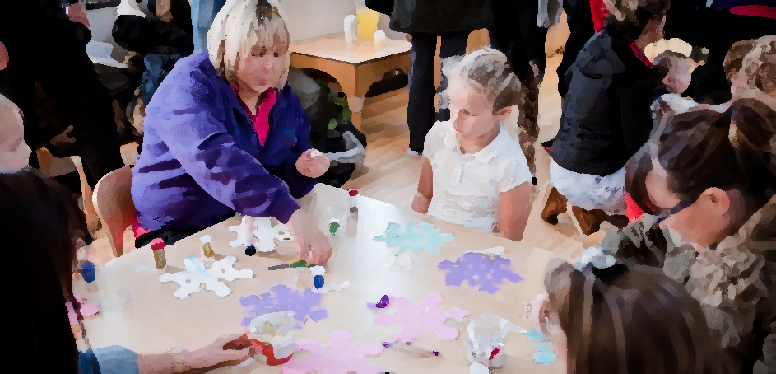

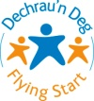

Morfa Children’s Centre, School Road, Morfa, Llanelli. SA15 2BN.
Tel No. 01554 742402
September -October 2025.
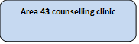
Money Matters session with Threshold
9:30am-11:30am
A session all about learning different way to manage money and how best to save money day to day.
Please contact a member of staff for more details.

Baby Massage and Baby Yoga
9:30am-11am
Free Baby Massage course for babies 8 weeks- 6 months. Please contact us for more information
9/09/2025 – 07/10/2025
Neurodiversity 4-week accredited workshop
9:30am-11:30am
A workshop to help parents best support their children through their neurodivergent diagnosis
Please contact a member of staff for more details.

Starting 24/9/2025

Baby Play
10:00am - 11:30am
Join Plant Dewi Family Centre for some crafts, singing and story time.
For babies under 12 months

Parent Toddler group
10:00am - 1:30am
Join Plant Dewi Family Centre for some crafts, singing and story time.
From Birth – 5yrs old

1:00pm – 3:00pm
Baby Massage
For Parents with Babies 0-6 months

Starting 11.11.14.
(for 5 weeks)
Referral only

Language and Play
12:30 - 2:00pm
Join us for some crafts, singing and story time whilst learning how to develop your child’s language.

3PM-5PM
Flying Start SPACE parenting programme Please book on via the Flying Start app.
15/9/25- 20/10/25

Wellbeing Session
1pm-2pm

Come and join the Plant Dewi team as they facilitate a wellbeing session for parents and children up to the age of 3.

Open Access Play
3pm - 4:30pm

A session for 7–11-year-olds where they can enjoy arts & crafts, outdoor play and so much more.

Cooking Pack collection.
12pm-3pm.
Pre booking required via the Plant Dewi team for a box of healthy ingredients to make a healthy meal at home.

Parent Toddler group
12:30 – 2:00pm

Join Plant Dewi Family Centre for some crafts, singing and story time.

From Birth – 5yrs old
WEDNESDAY

PM

Play Club 3pm - 4:30pm

A session for 4–6-year-olds where they can enjoy arts & crafts, outdoor play and so much more.

MONDAY
TUESDAY

Hywel Dda Flying Start
Health Visitor
‘Drop in’ Clinic.
9:30am - 12pm
THURSDAY
FRIDAY
Hywel Dda Perinatal Support Clinic

AM
Lunch Club
12pm – 12:30pm

Communities For Work +
Support for employment and Training

