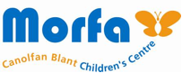

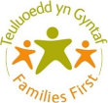
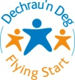
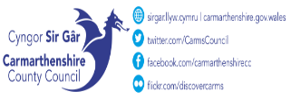
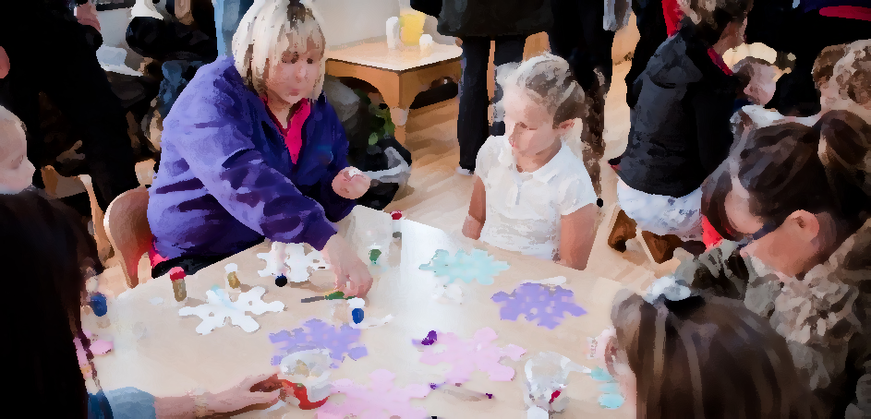
September-October 2026
Morfa Children’s Centre, School Road, Morfa, Llanelli. SA15 2BN.
Tel No. 01554 742402
Hywel Dda Perinatal Support Clinic

Hywel Dda Flying Start
Health Visitor
‘Drop in’ Clinic.
9:30am - 12pm

Lunch Club
12pm – 12:30pm

Play Club 3pm - 4:30pm
Every other week

A session for 4–6-year-olds where they can enjoy arts & crafts, outdoor play and so much more.
Registration needed before attending

Something for me 6-week course 9:30am-11:30am A 6-week course to learn something new each week from Yoga, cake decorating, beauty treatments and so much more! FREE childcare included *This course is fully funded by Communities for work and therefore, you must be unemployed to access the course* 14-09-26 – 19/10/26

Baby Massage with Baby Yoga 9:30am-11:00am Free 6-week Baby Massage course for babies 8 weeks- 6 months. Please contact us for more information
Course 1: 8/09/26 – 6/10/26 Course 2: 3/11-26 – 11/12/26

Creating Calm for Children 9:30am-11:30am A course to understand your child’s emotional and sensory world and using co-regulation to support emotional safety which will help strengthen your relationship with your child. 16/09/26 – 21/10/26
3PM-5PM

Baby Brain Development course 9:30am- 11am Come along and learn the incredible ways our babies’ brain develops. Suitable for parents expecting a baby and or parents of babies up to six months. 3/11/26 – 8/11/26
10.9.26 – 8.10.26

PM
Cooking Pack collection.
12pm-3pm.

Prebooking required via the Plant Dewi team for a box of healthy ingredients to make a healthy meal at home.

Open Access Play
3pm - 4:30pm
A session for 7–11-year-olds where they can enjoy arts &
crafts, outdoor play and so much more.
Registration needed before attending

WEDNESDAY

Parent Toddler group
12:30 – 2:00pm

Join Plant Dewi Family Centre for some crafts, singing and story time.

From Birth – 5yrs old

Language and Play
12:30 - 2:00pm

Join us for some crafts, singing and story time whilst learning how to develop your child’s language.

AM
Baby Play
10:00am - 11:30am

Join Plant Dewi Family Centre for some crafts, singing and story time.
For babies under 12 months

Wellbeing Session
1pm-2pm

Come and join the Plant Dewi team as they facilitate a wellbeing session for parents and children up to the age of 3.

Parent Toddler group
10:00am - 1:30am

Join Plant Dewi Family Centre for some crafts, singing and story time.
From Birth – 5yrs old

1:00pm – 3:00pm
Baby Massage
For Parents with Babies 0-6 months

Starting 11.11.14.
(for 5 weeks)
Referral only

FRIDAY
THURSDAY
TUESDAY
MONDAY

