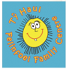
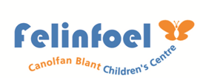
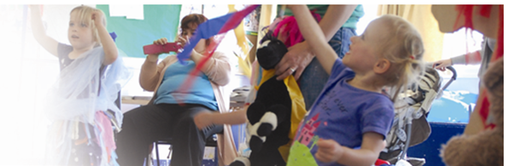
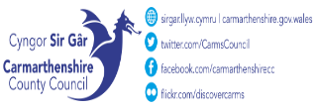
Felinfoel Children’s Centre Ysgol Maes Y Felin, Ynyswen Felinfoel Llanelli SA14 8BE 01554 742498

Tel No. 01554 742402
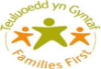
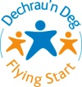 September – October 2026.
Fare Share Group
1.00pm-1.30pm
A food redistribution scheme for families
Booking Only

Play Club
3pm - 4:30pm
Every other week
A session for 4–6-year-olds where they can enjoy arts & crafts, outdoor play and so much more. Registration required before attending
Hywel Dda Flying Start
Health Visitor
‘Drop in’ Clinic.
9:30am – 11:00am
Hywel Dda Perinatal
Support Clinic
Appointments Only

Area 43 counselling services. Appointment only
Toddler Group/Tiny Talkers
9.30am – 11.30am
Parent/Toddler group
Drop-in session offering a warm welcome to all with free play, family activity time, outdoor play, snack and story/song time. For toddlers aged 0-3yrs.

Baby Massage with Baby Yoga
12:30pm-2pm
Free 6-week Baby Massage course for babies 8 weeks- 6 months. Please contact us for more information
14/09/2026 – 19/10/26
Family Fun Club
3.00-4:30pm
For families with children in lower primary school. Drop in after school for some family fun. Free play, crafts and after school snack.

Open Access Play
3pm - 4:30pm
A session for 7–11-year-olds where they can enjoy arts & crafts, outdoor play and so much more. Registration required before attending

Courses & Workshops
9.15am– 11.15am

Join us for cooking and craft workshops

3PM-4-30PM

PM
Toddler Group
9.30am – 11.30am
Parent/Toddler group
Drop in session offering a warm welcome to all with free play, family activity time, outdoor play, snack and story/song time. For toddlers aged 0-3yrs.

12/06/24 – 17/07/24

Baby Group
9.30am – 11.30am
A drop-in session for parents & babies –ideal for all babies until they are more mobile and ready for toddlers.

WEDNESDAY

AM

FRIDAY
THURSDAY
TUESDAY
MONDAY

